**Calibration of Models:Need for calibration**

Suppose we are doing 2-class classification and predict output y = 0 or 1.

Given training data we train model f(x) and after this if we give query point xq to f() then it predict yq (1 or 0)

But sometimes we want to predict probability as well like we want to predict Probability of yq = 1 given xq on model f.

But it may or may not return actual probability of yq = 1 given xq.

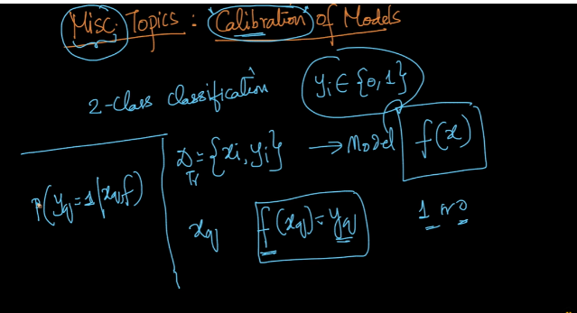

For ex: in naïve bayes it predict probability of yq =1 or 0 given xq and how it predicts is given below in image, but it doesn’t predict exact probability it predict approximate probability and then we predict whether it belongs to class 1 or not by comparing which probability is more.

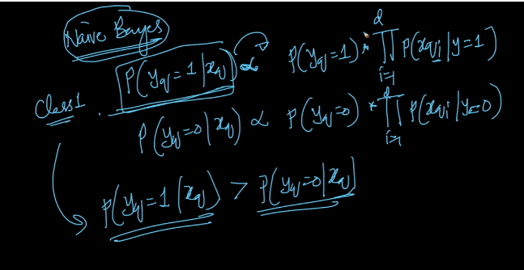

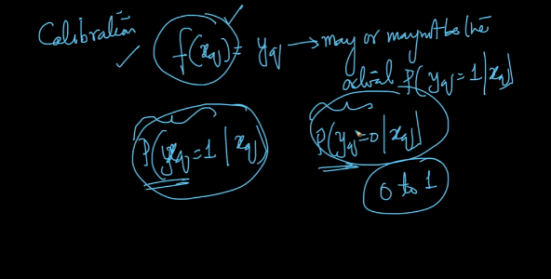

As we seen above it return approximate probability not actual but why we need actual probability?

Suppose we need to find 2-class log loss and it is given in below image and for this we need actual probability.

Therefore what calibration do is it use model and calibrate it to give actual probability.

So the proper flow is shown below.

We give data point xq to model f and then it predicts yq , now we give it to calibration model to get actual probability

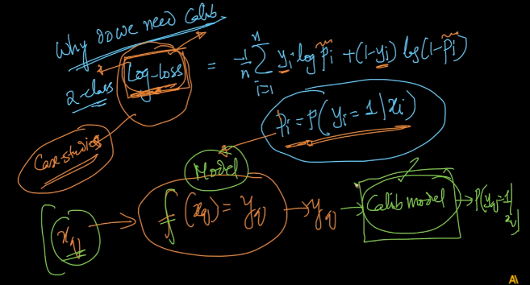

Comments :

